In 2015, after moving closer to school, I decided to forego my parking pass in favor of biking to school. Since then, it has rained on me almost every single day. However, that has mostly not kept me from biking. Here is why I decided to bike to school this year with consideration to taking a summer semester and assuming class was held 5 days a week:

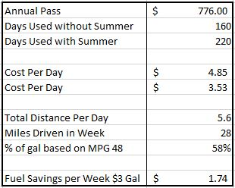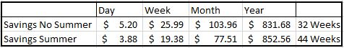

An important point to note, is that this decision has not affected my commute time. When driving, my commute time was 15 to 20 minutes. With biking it takes around the same amount of time, but now I can bike right up to the building. The parking lot I was originally assigned was about as far away from everything as it could possibly be. According to google maps, it cuts off about 1.2 miles of walking bus that I had to do.

I did have to purchase more bike appropriate clothing, but as clothing is multi-purpose I will forego calculating them in the total cost. I’ve had the commuter bike for years and so far I have only had to replace one tire and inner tube. These costs have been negligible compared to the savings.

Update:

I have started driving to school again, but do not have a parking pass. I have found areas of free parking that are only .01-.03 miles away from my old school assigned lot. Read this article for more information